5.1 The Paradox of SLAM
Simultaneous Localization and Mapping (SLAM) is one of the most important problems in modern robotics. Nearly every autonomous robot must answer two fundamental questions:
- Where am I?
- What does the world around me look like?
Unfortunately, these two questions depend on each other, creating what is often called the SLAM Paradox or the SLAM Chicken-and-Egg Problem.
- To estimate its own position (localization), a robot needs an accurate map.
- To build an accurate map (mapping), the robot must know its position.
[ Mapping ]
│
▼
┌─────────────────┐
│ SLAM Loop │
└─────────────────┘
▲
│
[ Localization ]
Because neither piece of information is known initially, the robot must solve both problems simultaneously.
When a robot enters an unfamiliar environment, it continuously:
- Estimates its position.
- Collects sensor measurements.
- Updates its map.
- Improves its position estimate.
- Updates the map again.
This cycle repeats hundreds or even thousands of times during operation.

Why SLAM Is Important
Without SLAM, autonomous robots would struggle to operate in unknown environments.
Imagine placing a robot in:
- A new office building
- A warehouse
- A hospital
- A classroom
- A cave on another planet
The robot has no prior knowledge of the environment.
SLAM allows it to explore, build maps, and determine its location at the same time.

The Mapping Problem
The mapping portion of SLAM focuses on answering:
"What does the environment look like?"
The robot uses sensors such as:
- Cameras
- LIDAR
- Distance Sensors
- Depth Sensors
to identify:
- Walls
- Furniture
- Obstacles
- Doorways
- Landmarks
Each sensor measurement contributes new information to the robot's internal map.

Example: Mapping a Classroom
Suppose a robot enters a classroom for the first time.
Initially the map is empty:
? ? ? ? ?
? ? ? ? ?
? ? ? ? ?
As the robot moves and scans:
? ? Wall ?
? Desk ? ?
? ? ? Door
The robot gradually fills in missing information.
Over time the map becomes more complete and accurate.

The Localization Problem
Localization focuses on answering:
"Where am I within the map?"
The robot estimates its position using information from:
- Wheel encoders
- GPS
- Cameras
- Inertial sensors
- LIDAR
Suppose the robot believes it is located at:
(x = 2, y = 3)
New sensor measurements are then compared against the map.
If the observations match expected landmarks, the robot gains confidence that its position estimate is correct.
If they do not match, the position estimate must be corrected.

VEX AIM Example: Exploring a Classroom
Imagine a VEX AIM robot entering a classroom it has never seen before.

Initial State
The robot knows:
Position = Unknown
Map = Unknown
``

Sensor Measurements
The AIM robot uses:
- Distance Sensor
- Optical Sensor
- Inertial Sensor
The robot begins detecting:
- Walls
- Desks
- Chairs
- Colored objects

Building the Map
As sensor measurements arrive, the robot creates an occupancy grid:
□ □ □ □ □
□ ■ ■ □ □
□ □ □ □ □
Where:
- □ = Free Space
- ■ = Obstacle

Localization
The robot also tracks:
- Distance traveled
- Heading angle
- Detected landmarks
This allows the AIM robot to estimate its current position while simultaneously building the map.
This is a simplified form of the same challenge faced by professional autonomous robots.

VEX AIM Example: Classroom Delivery Robot
Suppose a VEX AIM robot must deliver supplies from one side of the classroom to another.
The robot begins with:
No map
Unknown location
As it moves:
- Sensors detect desks and walls.
- A map is created.
- The robot determines where it is on that map.
- The route to the destination becomes clearer.
Eventually the robot develops both:
- A map of the classroom
- Knowledge of its own location
This is the essence of SLAM.

Real-World Example 1: Robotic Vacuum Cleaner
Modern robotic vacuum cleaners use SLAM extensively.

Mapping
The vacuum creates a map of:
- Rooms
- Hallways
- Furniture
- Obstacles

Localization
It continuously tracks:
- Its current room
- Direction of travel
- Distance from the charging dock
Without SLAM:
- Cleaning would be random.
- Rooms might be cleaned repeatedly.
- Some areas might be missed.
With SLAM:
- Coverage is systematic.
- Navigation is efficient.
- The robot can return directly to its charger.

Real-World Example 2: Warehouse Robots
Warehouse robots frequently operate in complex facilities.
The robot must determine:
Where am I?
Which aisle am I in?
Which shelf am I approaching?
Using SLAM, the robot creates a map while tracking its own position.
This allows thousands of robots to safely move inventory throughout large warehouses.

Real-World Example 3: Self-Driving Cars
Self-driving vehicles combine:
- Cameras
- LIDAR
- Radar
- GPS
to build detailed maps of their surroundings.
The vehicle continuously localizes itself relative to:
- Roads
- Intersections
- Lanes
- Buildings
SLAM helps the vehicle maintain accurate positioning when GPS signals are weak or unavailable.

Real-World Example 4: Mars Rovers
Mars rovers provide one of the most famous examples of SLAM.
When a rover lands on Mars:
- No detailed local map exists.
- Human operators are millions of miles away.
The rover must:
- Build maps of the terrain.
- Determine its position.
- Plan safe routes around rocks and craters.
Because communication delays are so large, much of this process must occur autonomously.

Why SLAM Is Difficult
Several challenges make SLAM hard:

Sensor Noise
Sensors are imperfect.
For example:
- Cameras can be blurry.
- LIDAR can be noisy.
- Encoders can experience wheel slip.

Position Drift
Small errors accumulate over time.
A robot that believes it moved:
1.0 m
may have actually moved:
0.95 m
Repeated errors cause localization drift.

Dynamic Environments
People and objects move.
A map created yesterday may not match today's environment.

Applications of SLAM
SLAM is used in:
✅ Robotic vacuums
✅ Warehouse robots
✅ Self-driving vehicles
✅ Delivery robots
✅ Autonomous drones
✅ Search-and-rescue robots
✅ Mars rovers
✅ Agricultural robots

Multiple-Choice Question
A VEX AIM robot enters a classroom it has never seen before. Which statement best describes the SLAM problem?
A. The robot must increase its motor speed while reducing battery use.
B. The robot must simultaneously determine its location and build a map of the environment. ✅
C. The robot must choose between mapping or localization.
D. The robot only needs to detect obstacles.
Correct Answer: B
Explanation:
SLAM stands for Simultaneous Localization and Mapping. The robot must determine where it is while simultaneously building a map of its surroundings.

CodeLens Activity
Consider the following pseudocode:
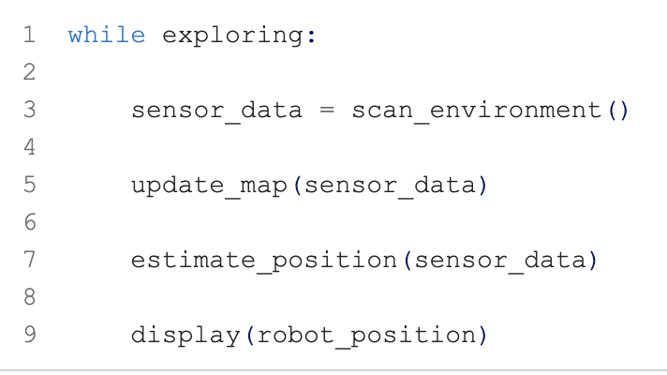
while exploring:

sensor_data = scan_environment()

update_map(sensor_data)

estimate_position(sensor_data)

display(robot_position)

Question
What is the robot doing during each iteration of the loop?
A. Only building a map
B. Only determining its location
C. Simultaneously updating its map and estimating its position ✅
D. Calculating wheel speed only
Correct Answer: C

Explanation
This loop demonstrates the core idea of SLAM. The robot uses new sensor measurements to:
- Improve its map of the environment.
- Improve its estimate of where it is located within that map.
Both processes occur simultaneously, allowing the robot to navigate effectively through unknown environments.

